Software Requirement Specification for DBM

Table of Contents

1. Introduction 3

1.1 Purpose 3

1.2 Document Conventions 3

1.3 Intended Audience and Reading Suggestions 3

1.4 Product Scope 3

1.5 References 3

2. Overall Description 4

2.1 Product Perspective 4

2.2 Product Functions 4

2.3 User Classes and Characteristics 6

2.4 Operating Environment 6

2.5 Design and Implementation Constraints 6

2.6 User Documentation 6

2.7 Assumptions and Dependencies 6

3. External Interface Requirements 7

3.1 User Interfaces (Web App) 7

3.1.1 Main page 7

3.1.2 Registration Page 8

3.1.3 Login Page 9

3.1.4 All Courses 9

3.1.5 Courses Details 10

3.1.6 Lecture Details 10

3.1.7 Notes 11

3.1.8 Course Content 11

3.1.9 Assignments 12

3.1.10 Player 12

3.1.11 About 13

3.2 User Interfaces (Desktop App) 13

3.2.1 Main Page 13

3.2.2 Player 14

4. Non Functional Requirements 14

4.1 Performance Requirement 14

4.2 Safety Requirement 14

4.3 Security Requirement 14

4.4 Software Quality Attributes 14

# Introduction

## Purpose

The purpose of this document is to present a detailed description of the hardware and software-based project DBM (Digital Board Marker). It will explain the purpose and features of the project, the interfaces of all the hardware and software communication and navigation, what the software will do and the constraints under which it must operate. This document is intended for users of the software and also potential developers.

## Document Conventions

This Document was created based on the IEEE template for System Requirement Specification Documents.

## Intended Audience and Reading Suggestions

• Typical Users, such as students and teachers, who want to use DBM for uploading and view lectures with very low bandwidth.

• Advanced/Professional Users, such as engineers or researchers, who want to use DBM for more researches in computer vision and resolution of bandwidth issues.

• Programmers who are interested in working on the project by developing it further or fix existing bugs.

## Product Scope

Digital board marker mainly cover academic area the main purpose is to provide each and every student all the lectures with better quality and less bandwidth because in Pakistan we students face this issue the most, as we know it cannot be resolved in near future we have to work something out for this issue and that’s where this system will work it will provide an interface to all the students which have all the lectures of their respective subjects from their respective teachers which can be streamed online and downloaded for offline to play later on at very low bandwidth. It will provide all the assignment related material and lectures at same platform to students. It is the new revolution in the academic field. Although it covers industry and researches as well.

## References

IEEE Template for System Requirement Specification Documents:

<https://goo.gl/nsUFwy>

Bandwidth issues in gaming industry:

<https://www.activo.ca/blog/4-reasons-you-still-have-bandwidth-problems/>

# Overall Description

## Product Perspective

Digital Board Marker is developed for recording lectures as animations, saving the size up to 100 times as compared to regular video lecture. It is developed for students who face problem in jotting down the lecture and cannot focus on the lecture.

It is an open source project and it has a very active developer team to support it and provide feedback to users. It is developed to run on Windows, Android and Web Browser.

## Product Functions

**Desktop and Mobile Application**

File:

* Open: Loads an existing Lecture file.
* Open Recent: Loads one of the displayed, recently opened Lecture files.
* Properties: Displays some properties of the Lecture (such as the title, duration and number of topic tags) which can be edited.
* Save: Saves the edited lecture file without changing its name or directory.
* Save as: Saves the lecture file and gives the user the ability to change its name or directory.
* Exit: DBM app shuts down

Player Window:

* Resize: Resize the application player view window.
* Play/Pause: Plays or Pauses the lecture animation.
* Audio control: Controls the audio level.
* Next: Play next lecture in lecture playlist.
* Previous: Play previous lecture in lecture playlist.
* Fast Forward: Speeds up lecture animation and audio track as well.
* Slow down: Slower the animation speed and also audio track.
* Timeline: Displays the timeline tab.

Splash Screens:

* Welcome: Displays the Welcome window.

Help:

* Check for Updates: Displays the plugins that can be updated to newer versions
* About: Displays the logo of DBM, which licenses are being used, the product version and other info.

**Web Application**

Main Page:

* Login/Registration: Displays the Login and Registration pages in which students as well as teachers or instructors can be registered and login afterwards.
* Course Section: Displays all available courses to student and instructor
* Lectures Section: Includes lecture hierarchy and lecture player

Login/Registration:

* Registration Page: Requests First name, Last name, CNIC, Degree, Email, Country, Education institution, Password from user being registered and sends a verification email.
* Login Page: Require Username and password from user.

Course Section:

* All Courses Page: Includes all available courses and display them to the respective user or instructor.
* Registered Courses: Displays the courses in which current user is registered.

Lecture Hierarchy:

* Course Content Page: Lectures and the corresponding date.
* Configuration: Preferences about how the data is presented.
* Add Lecture: Manage recently recorded unlisted lectures
* Search: Stand Search functionality

Lecture Player:

* Resize: Resize the application player view window.
* Play/Pause: Plays or Pauses the lecture animation.
* Audio control: Controls the audio level.
* Next: Play next lecture in lecture playlist.
* Previous: Play previous lecture in lecture playlist.
* Fast Forward: Speeds up lecture animation and audio track as well.
* Slow down: Slower the animation speed and also audio track.
* Timeline: Displays the timeline tab.

Splash Screens:

* Welcome: Displays the Welcome window.

Active Learning Control Panel:

* Show controls such as on/off and other button controls under this panel.

## User Classes and Characteristics

* Typical Users, such as students, who want to use DBM for watching online lectures as well as download to view it in offline mode later after.
* Professional Users, such as Instructors or teachers who want to use DBM for editing and annotations.

## Operating Environment

* Windows 7
* Windows 8
* Windows 10
* Android 4.0 and higher
* Web Browser with HTML5

## Design and Implementation Constraints

DBM is developed in C#, it uses .net Core as build platform of web application. Desktop application is developed in C# as well. It is developed as windows form application in visual studio 2015. Android app is developed in Android studio that features editing and annotation of video lecture and requires name, category and course name of the currently being uploaded lecture

## User Documentation

There is a quick start guide available on the website of DBM

## Assumptions and Dependencies

DBM web app is developed in C# visual studio 2015. Web application requires any browser that supports HTML5 and CSS3. Supported browsers are Chrome, Safari, Firefox latest version

DBM desktop app is developed as windows form application in visual C#. It requires some runtime libraries to be installed on client’s machine such as:

* Visual Redistributables
* .Net Framework 4.5

DBM Android app requires android version above 4.0, stable internet connectivity and QHD Display resolution in minimum.

# External Interface Requirements

## User Interfaces (Web App)

### Main page

This is the main page of application from where user can navigate to all pages.

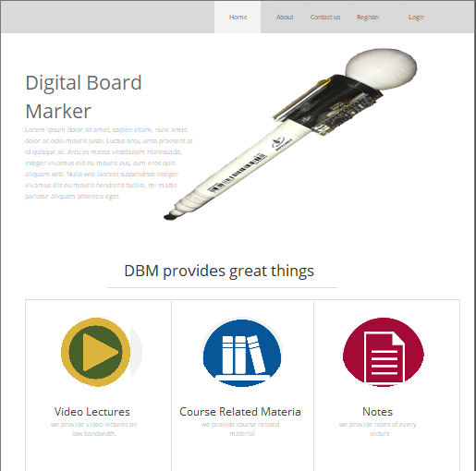

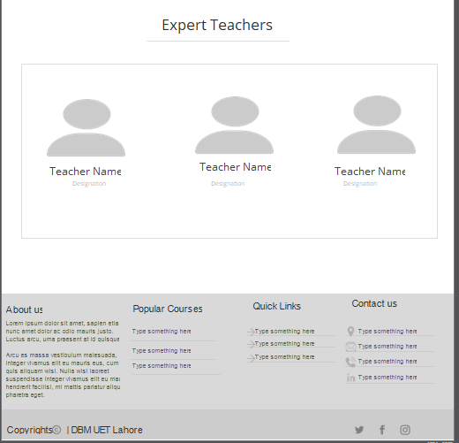

### Registration Page

From main page user can navigate to registration page and register itself as a new user in our system

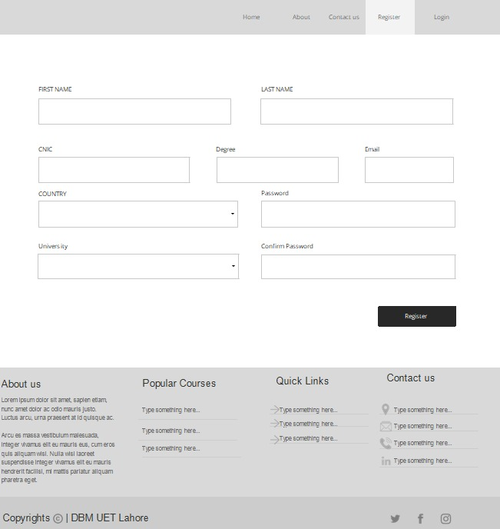

### Login Page

After registration user can go to login and perform

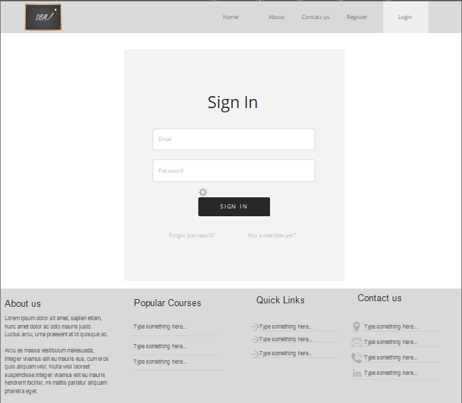

### All Courses

After log in user can see all the courses uploaded

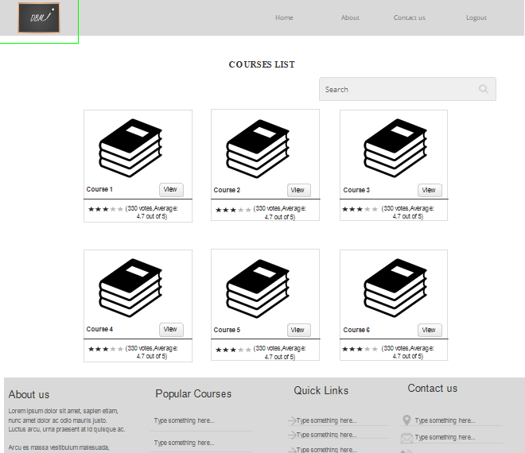

### Courses Details

User can see each course details by clicking on the view button.

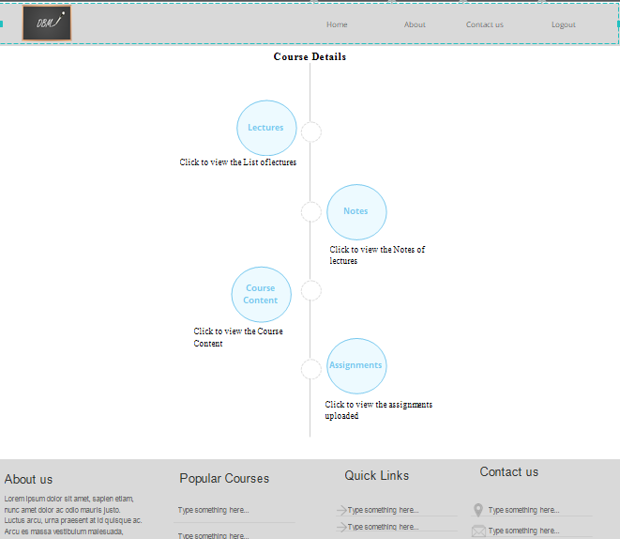

### Lecture Details

User can go to lecture details of each course by clicking Lecture button.

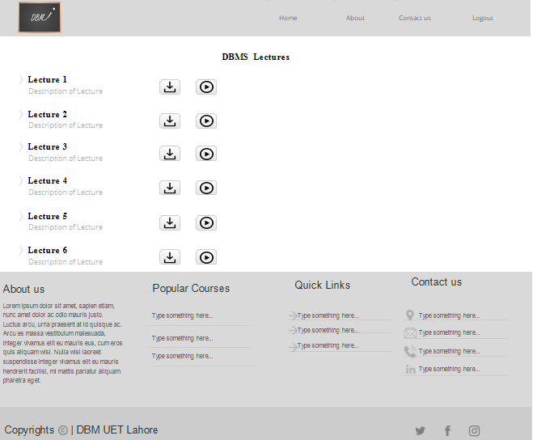

### Notes

Students can view lectures notes by clicking on notes button from course details page.

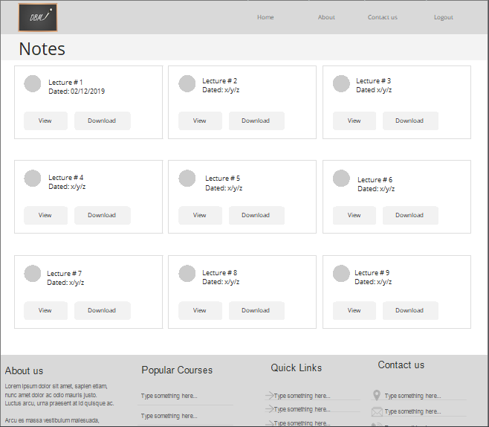

### Course Content

User can see course content like books by clicking on course content button on course details page. If user is teacher then he will see upload button.

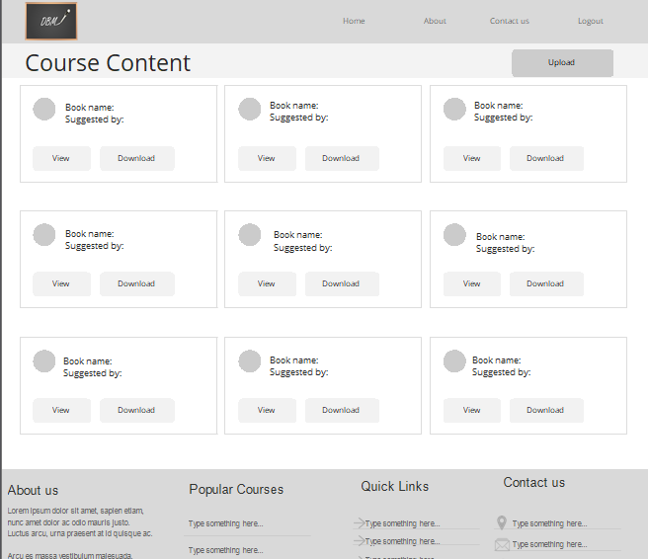

### Assignments

User can view all the assignments uploaded by teacher. If user is a teacher he can upload the assignments.

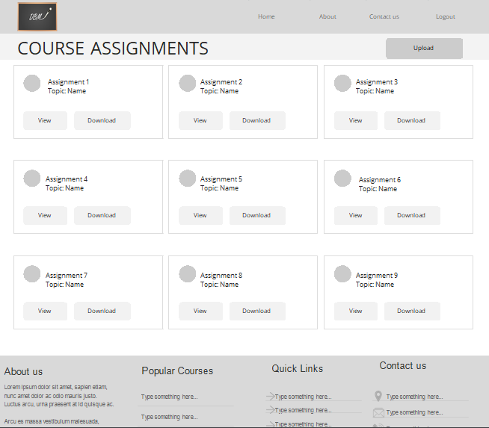

### Player

User can play the lecture online by clicking the play icon in front of each lecture in lecture details page.

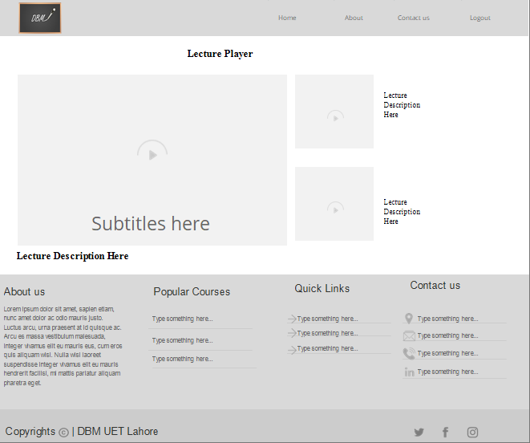

### About

Anyone can see the about page. This shows information about are website and system.

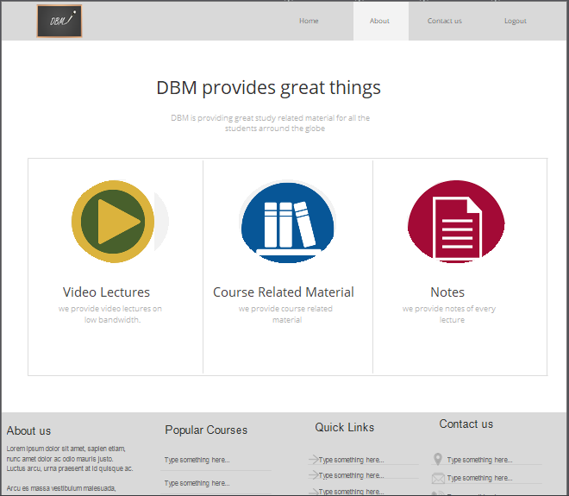

## User Interfaces (Desktop App)

### Main Page

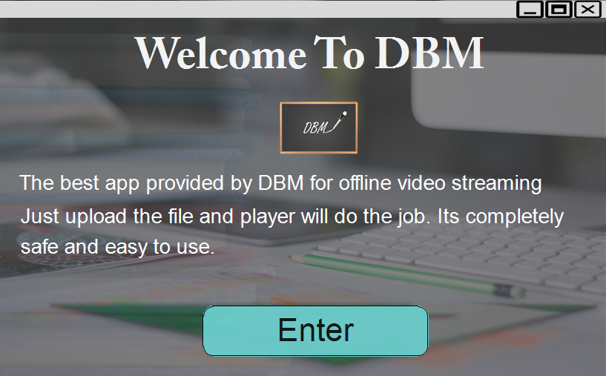

### Player

User will upload the lecture zip file downloaded from website to play it in offline player.

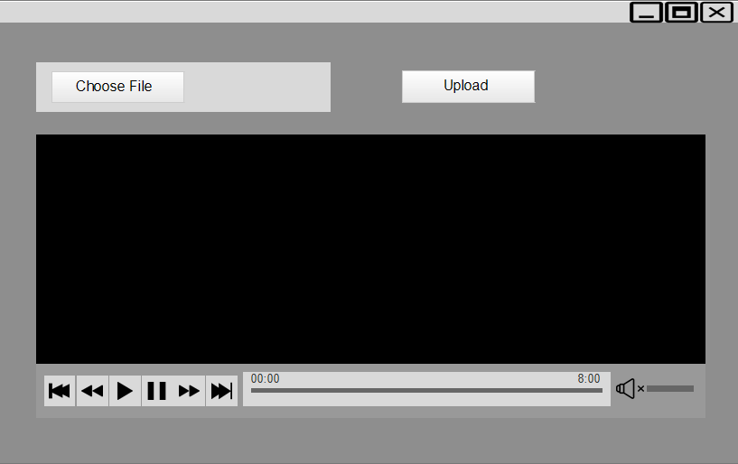

# Non Functional Requirements

## Performance Requirement

Some performance requirements are listed below.

* The software should support the use of multiple users at a time.
* The database should be able to record thousands of records.
* Live streaming of lecture should also be possible within low bandwidth.
* Software should support the live streaming of multiple lectures at a time.
* No loss of data should occur while uploading the lecture.
* No loss of data should occur while live streaming of lecture.

## Safety Requirement

The database may get crashed due to virus or operating system failure. So, it is required to take the database backup.

## Security Requirement

Some of the factors that are identified to protect the software from accidental and malicious attacks are discussed below.

* Assign certain function to different modules.
* Check data integrity for critical variables.

## Software Quality Attributes

* **Availability:** The system should be available on any time for use of multiple users.
* **Correctness:** The system should provide correct content and lectures of a specific subject.
* **Usability:** The system should satisfy a maximum number of user needs.
* **Confidentiality:** Software should allow only authorized users to access the System.
* **Portability:** Software should be portable to avoid any problem that may occur from moving one OS to another OS.
  + **Supportability:** Software should use proper naming conventions and coding standards.